In App store, install the Blynk app.

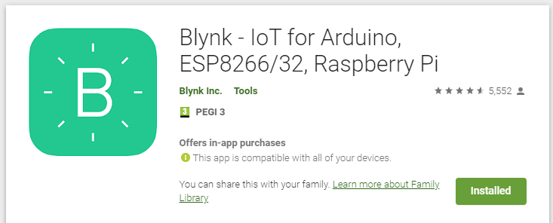
Go through the steps to create the account , and start a new project.

An Authentication token will be sent to you by email.

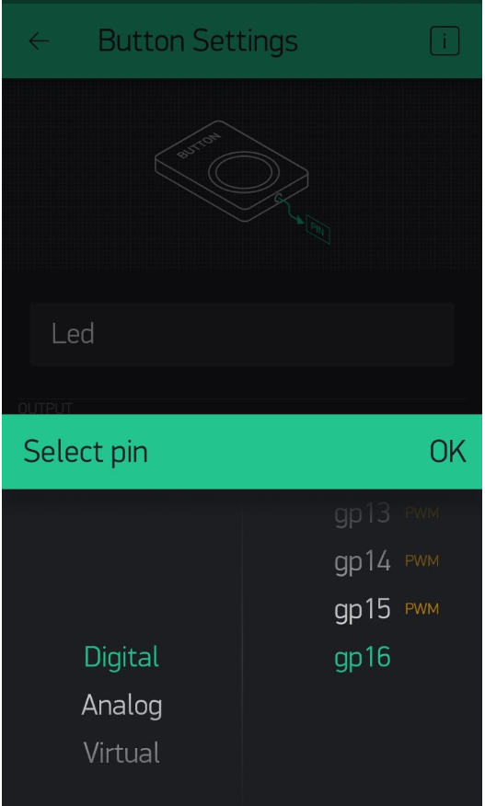
In the phone app, add a new Button and assign it pin 16 (where the BUILTIN_LED is connected on the board).

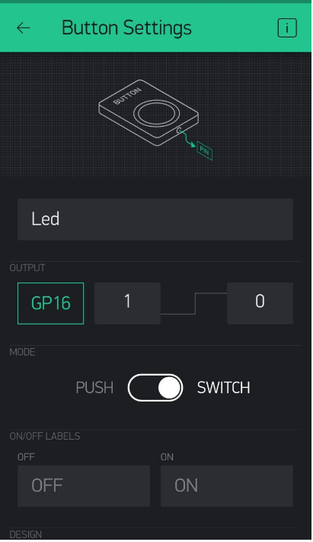

In the Arduino IDE, go to : Sketch → Include Library → Manage Libraries

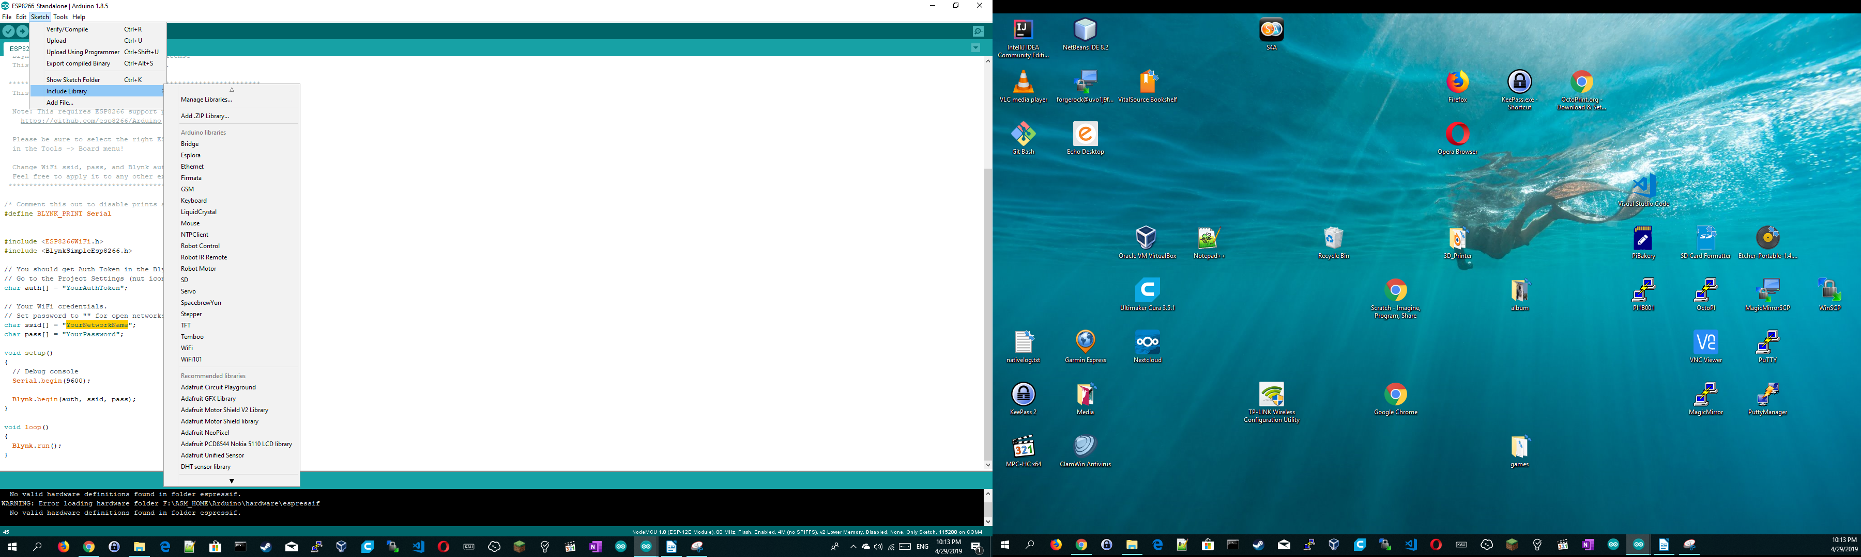

In the Textbox, type in “Blynk” and install the library “Blynk by Voldymyr ...”

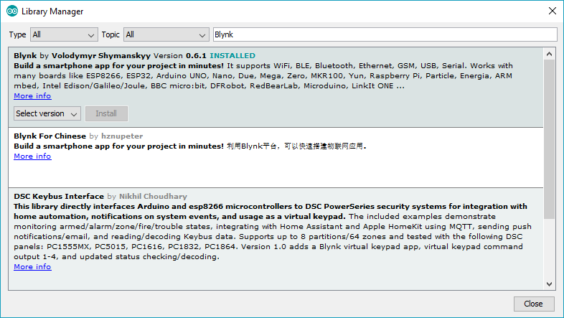

In the Arduino IDE, go to : Files → Examples → Blynk → Boards_WiFi → ESP8266_Standalone

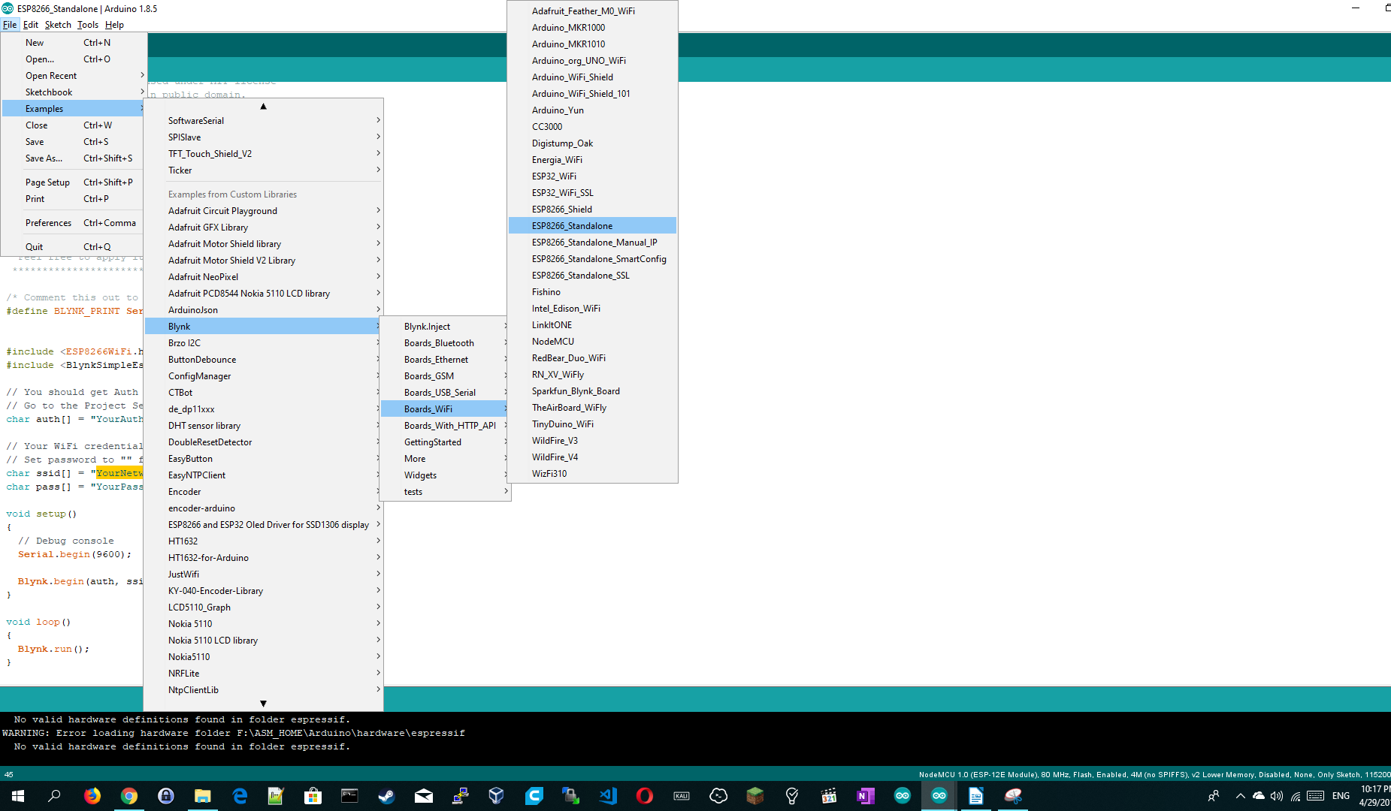

Modify the code accordingly:
char auth[] = "YourAuthToken(You should have this already in the email)";

char ssid[] = "YourNetworkName";
char pass[] = "YourPassword";

compile and upload the sketch.

In the Phone APP , press and un-press the button to notice the led is turning ON (LOW) and OFF(High).

A Two-way communication

Blynk can enable you to also to send data the other way, where the ESP8266 can control LED widget on your Blynk project and turn it on or off.

In this example you are going to control a led Widget on Blynk project using the ESP button connected at PIN: D5.

Go ahead and add LED widget to your project and assign it a INPUT of Virtual - V3 like the picture below.

In your code:

Create some new global variables outside any function

WidgetLED led1(V3);
int interruptPinD5 = D5;
bool ledState = false;

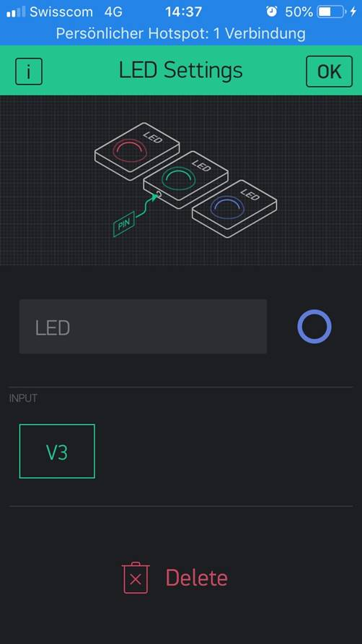
In the setup() function, initialize the PIN and the button interrupt

pinMode(interruptPinD5, INPUT_PULLUP);
attachInterrupt(digitalPinToInterrupt(interruptPinD5), handleInterruptD5, FALLING);
Blynk.begin(auth, ssid, pass);

Add this function:

void handleInterruptD5() {
Serial.print("D5:press:");
Serial.println(D5);

if(ledState){
led1.off();
ledState = false;
}else{
led1.on();
ledState = true;
}
}

Compile, upload and test your code. Whenever you press the button on the ESP board, the Led Widget should turn on and off in the Blynk project.

Please try this example with the attached sketch :
"Blynk_two_way_communication"

